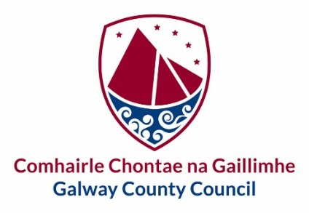
Oifig an Rúnaí,
Áras an Chontae,
Cnoc na Radharc,
Gaillimh.

10 Nollaig 2020

Chuig an gCathaoirleach and gach Ball den Choiste um Beartas Straitéiseach - Athrú Aeráide & Bithéagsúlacht

To The Chairman and Each Member of the Climate Change & Biodiversity Strategic Policy Committee

A Chara,
Iarrtar ort bheith i láthair ag Cruinniú den Choiste um Beartas Straitéiseach - Athrú Aeráide agus Bithéagsúlacht, a bheith á reáchtáil trí Teams agus a thionólfar Dé Céadaoin 16 Nollaig 2020 ag tosú ag 11.00 am.

You are hereby requested to attend a Meeting through Teams of the Climate Change & Biodiversity Strategic Policy Committee which will be held on Wednesday 16 December starting at 11.00 am.

Mise, le meas,

Aidan Cunningham
A/Riarthóir Cruinnithe / Meetings Administrator
Tel. 091 509221

C L Á R

- Confirmation of Minutes and Matters arising from Climate Change & Biodiversity Strategic Policy Committee Meeting held on 22nd October 2020

- Climate Adaptation Strategy – Update

- ESB EV Charging Infrastructure

- Light Pollution

- Active Travel Plan

- Galway’s Living Bog: Carrownagappul Bog Biodiversity Resources

- Date and Time of Next Meeting

- AOB

